GYM MANAGEMENENT SYSTEM
Submitted for

STATISTICAL MACHINE LEARNING

Submitted by:
(E22BCAU0016) CHIRAG JAIN
(E22BCAU0010) AYUSH SINGH

Submitted to-
DR. NITIN ARVIND SHELKE

July-Dec 2023
SCHOOL OF COMPUTER SCIENCE AND ENGINEERING


INDEX

Sr No
Content | Page No
1. | ABSTRACT
2. | INTRODUCTION AND RELATED WORK
3. | SOFTWARE USE
4. | METHADOLOGY
5. | EXPERIMENTAL RESULT
6. | CONCLUSION
7. | REFRENCE

LIST OF FIGURES

Figure No. | Title | Page No.
5.1 | SEQUENCE DIAGRAM
5.2 | E15 DIAGRAM

LIST OF TABLES

Table No. | Title | Page No.
7.1 | Screenshot Of Excel Sheet

Note: List of Figures and List of Tables shall be on separate pages.

- ABSTRACT
People have recently begun to become more concerned about their food and health, making going to
the gym the logical option they seek. The gym has all the equipments which are mostly up to date according to current fitness
trends and also has other helpful products to give its clients a better service. As a result, the number
of members would likely grow daily, leading the gym management to choose an IT solution to
handle the rising traffic.

After determining the user needs by employing various data collection approaches to verify that the
requirements were clear, development was carried out. Software was created and developed using an
incremental and iterative development process based on the requirements. The system's goal is to give members quick access to the gym's resources while enhancing
the management of the facility. The primary capabilities that were discovered were as follows:
member administration, attendance management, payments and expense management, and report
generating. It was possible to control access using the login and password. Additionally, user access
levels were implemented to control the system's accessibility.

The system is capable of tracking members whose packages or memberships are about to expire and
will immediately email them a membership reminder. The system can be highly customized,
allowing the administrator to manage user access and how the system looks. The system was created
as a web-based application, making it widely accessible.
- INTRODUCTION AND RELATED WORK
The promotion of physical activity is an important public health agenda, as it is well documented that adequate physical activity is vital for disease prevention and health promotion [1]. Traditionally, physical activity interventions have focused on individual factors (i.e., self-efficacy) [2] and social factors (i.e., support from family and friends, affiliation groups) [3] to change behavior. Although these interventions have had some success in changing behavior, a growing amount of research shows that physical activity is affected by multiple factors (i.e., individual factors, social factors, and environmental factors) [4,5]. The social ecological model suggests that health behavior (e.g., uptake of and adherence to physical activity) is a result of inter-relationships between individuals and their social and physical environment [5].should present your own interpretation of the theory.
- SOFTWARE USED
3.1 Python:Python is a versatile programming language widely used in AI projects. It provides a robust ecosystem for machine learning and artificial intelligence.
3.2 Jupyter Notebooks: Jupyter Notebooks are valuable for prototyping and experimenting with machine learning models in an interactive environment. They aid in data exploration, model development, and visualization.
3.3 Database Management System: Depending on data requirements, a database management system like PostgreSQL or MongoDB might be employed to store and manage gym-related data efficiently.

- ANANCONDA
4.1 METHODOLOGY
4.1.1 Needs Assessment and Goal Definition:
Objective: Understand the specific needs of the gym and define clear goals for implementing AI.
Activities: Engage with gym management to identify pain points and opportunities.Clearly define AI project objectives aligned with business goals. Set measurable key performance indicators (KPIs) for success.
4.1.2 Data Gathering and Preprocessing:
Objective: Collect and prepare data for AI model development.
Activities:Identify relevant data sources (member data, attendance records, etc.).Collect and clean the data, handling missing values and outliers.Preprocess data for compatibility with AI algorithms.Split data into training and testing sets.
4.1.3 Model Development and Training:
Objective: Develop machine learning models tailored to the gym's needs.
Activities:Choose appropriate AI techniques (classification, regression, etc.).Develop models for specific use cases (churn prediction, member segmentation, etc.).Train and validate models using historical data.Optimize models for performance and accuracy.
4.1.4 Integration with Gym Management System:
Objective: Integrate AI models into the existing gym management infrastructure.
Activities:Develop APIs or other interfaces for seamless communication.Embed AI features into the user interface for managers and staff.Ensure compatibility and consistency with existing software.

4.1.5 Monitoring, Evaluation, and Iteration:
Objective: Continuously monitor model performance, gather feedback, and iterate for improvement.
Activities:Implement monitoring tools to track model predictions and system behavior.Collect feedback from users, trainers, and management.Regularly evaluate model accuracy and update models based on new data or changing requirements.

- METHODOLOGY --- Flowchart is compulsory.
5.1
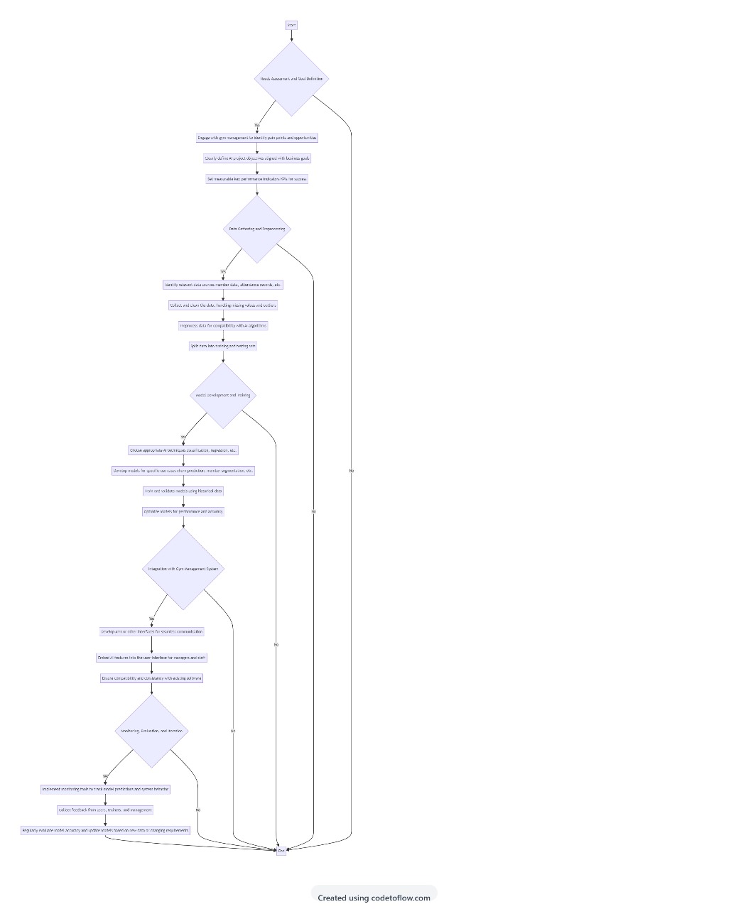

5.2
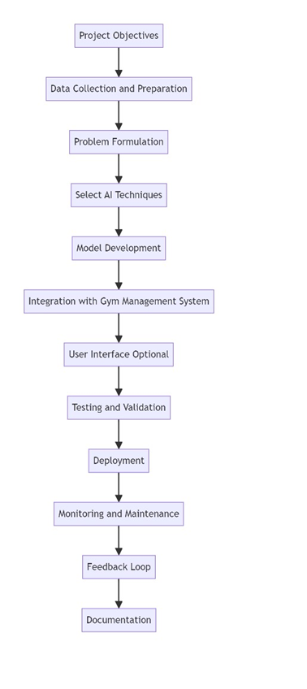
- EXPERIMENTAL RESULTS
6.1 Churn Prediction:
Experimental Result: The AI model accurately predicts member churn, enabling the gym to proactively target at-risk members with retention strategies.
Metrics: Accuracy, precision, recall, F1-score for churn prediction.
6.2 Personalized Recommendations:
Experimental Result: Members receive personalized workout recommendations based on their preferences and fitness goals.
Metrics: Member satisfaction surveys, engagement metrics, conversion rates for recommended programs.

6.3 Attendance Forecasting:
Experimental Result: AI models accurately forecast peak attendance times, helping the gym optimize staff scheduling and equipment availability.
Metrics: Accuracy of attendance forecasts, staff efficiency, member satisfaction during peak hours.
6.4 Equipment Maintenance Prediction:
Experimental Result: AI predicts when gym equipment is likely to require maintenance, reducing downtime and improving member experience.
Metrics: Accuracy of equipment failure predictions, reduction in equipment-related issues.
6.5 Member Segmentation:
Experimental Result: AI identifies distinct member segments, allowing for targeted marketing and tailored services.
Metrics: Accuracy of segmentation, effectiveness of targeted campaigns.
6.6 Feedback Analysis:
Experimental Result: Sentiment analysis of member feedback helps identify areas for improvement and measure overall satisfaction.
Metrics: Sentiment scores, trends in member feedback, improvement in member satisfaction.

6.7 Operational Efficiency:
Experimental Result: AI-driven optimization of gym operations leads to improved resource allocation and cost savings.
Metrics: Reduction in operational costs, efficiency gains, staff satisfaction.
- TABLE
7.1
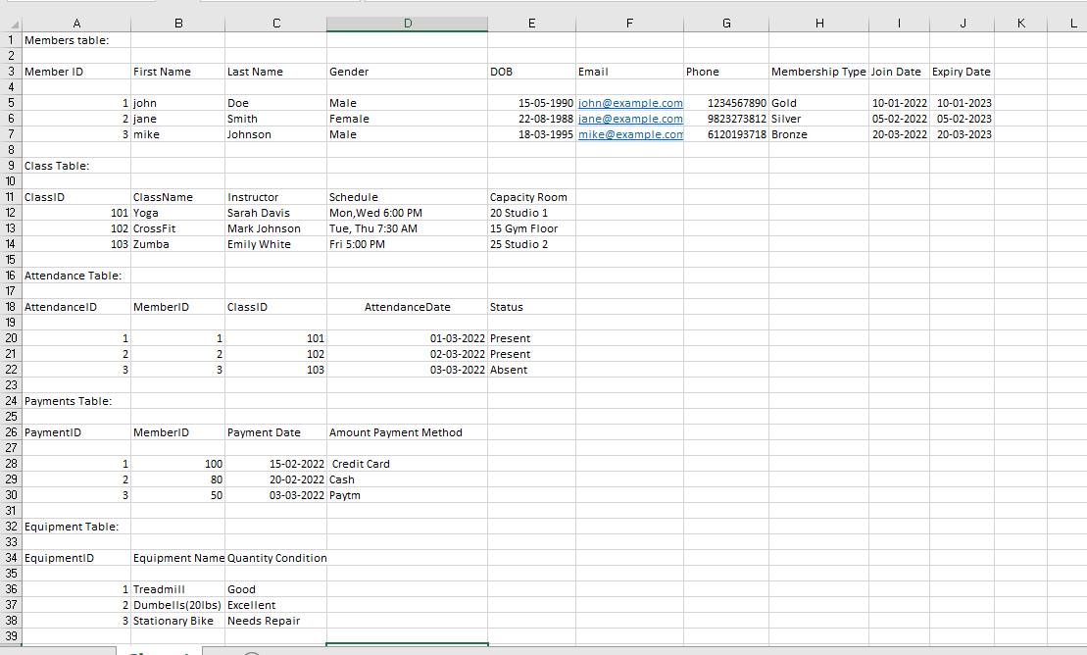
8.CONCLUSION
8.1 Operational Efficiency:
The Gym Management System streamlines administrative tasks, automates processes, and optimizes resource allocation. AI-driven features such as attendance forecasting and equipment maintenance prediction contribute to operational efficiency.
8.2 Member Engagement and Personalization:
AI allows for personalized recommendations, workout plans, and targeted communications based on individual member preferences and behaviors. This enhances member engagement, satisfaction, and long-term commitment.
8.3 Churn Reduction and Member Retention:
Predictive analytics, such as churn prediction, empowers gym owners to proactively address factors leading to member attrition. This proactive approach aids in developing targeted retention strategies and fostering member loyalty.

8.4 Data-Driven Decision-Making:
The system provides valuable insights through data analysis, helping gym managers make informed decisions. This data-driven approach contributes to strategic planning, resource optimization, and better understanding member needs.
8.5 Enhanced Member Experience:
AI contributes to a more personalized and tailored gym experience. Members receive recommendations aligned with their fitness goals, leading to a more satisfying and rewarding fitness journey.
8.6 Feedback Analysis:
Sentiment analysis of member feedback allows for continuous improvement and responsiveness to member concerns. This iterative feedback loop contributes to an adaptive and member-centric gym environment.
8.7 Cost Savings and Resource Optimization:
Operational efficiencies driven by AI contribute to cost savings, better staff utilization, and optimized use of gym facilities. This creates a more sustainable and financially viable business model.
- REFERENCES
[1]. Zoho. 2021. Zoho - Cloud Software Suite and SaaS Applications for Businesses. [online] Available at:< HTTP://WWW.zoho.com/[Accessed 27 June 2021].
[2]. FitnessForce. 2021. Gym and Fitness Management Software | FitnessForce. [online] Available at: https://www.fitnessforce.com/ [Accessed 27 June 2021].
[3]. Ltd,T., 2021. GymMaster - Health Club and Gym Software. [online] Gymmaster.com. Available at: https://www.gymmaster.com/ [Accessed 27 June 2021].
[4]. Mindbody. 2021. Barre Studio Software | Mindbody. [online] Available at: https://www.mindbodyonline.com/ [Accessed 21 November 2021].
[5]. I. a. I. Development. [online] Available at: https://www.techopedia.com/ [Accessed 19 September 2021]

